Exercises

* Change the text in *Text* widget inside *MaterialApp* to your name.

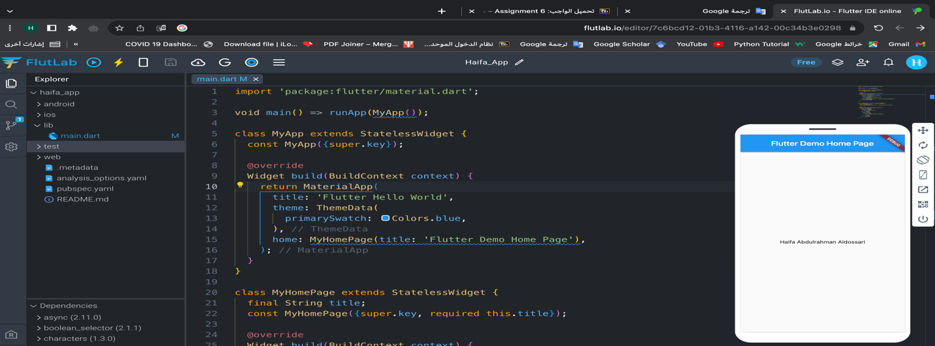

import 'package:flutter/material.dart';

void main() => runApp(MyApp());

class MyApp extends StatelessWidget {

const MyApp({super.key});

@override

Widget build(BuildContext context) {

return MaterialApp(

title: 'Flutter Hello World',

theme: ThemeData(

primarySwatch: Colors.blue,

),

home: MyHomePage(title: 'Flutter Demo Home Page'),

);

}

}

class MyHomePage extends StatelessWidget {

final String title;

const MyHomePage({super.key, required this.title});

@override

Widget build(BuildContext context) {

return Scaffold(

appBar: AppBar(

title: Text(title),

),

body: Center(

child: Text(

'Haifa Abdulrahman Aldossari',

),

),

);

}

}

* Change the color of the *Text* widget to **white**. (Hint: lookup TextStyle widget)

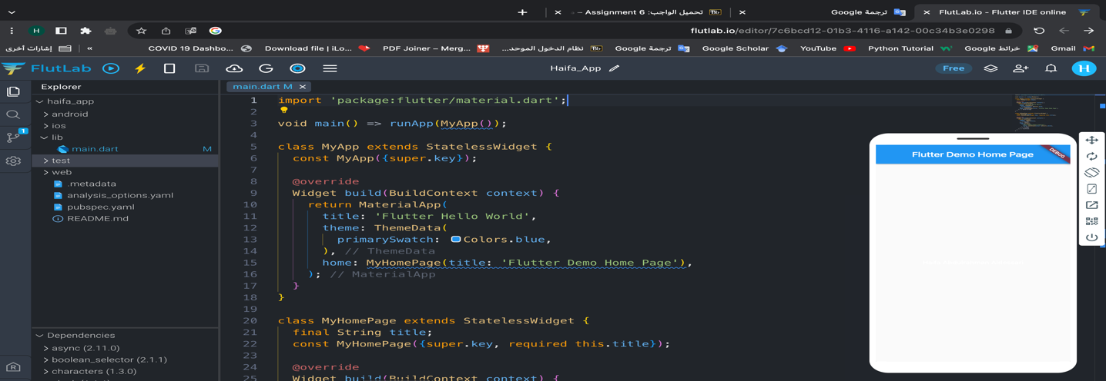

import 'package:flutter/material.dart';

void main() => runApp(MyApp());

class MyApp extends StatelessWidget {

const MyApp({super.key});

@override

Widget build(BuildContext context) {

return MaterialApp(

title: 'Flutter Hello World',

theme: ThemeData(

primarySwatch: Colors.blue,

),

home: MyHomePage(title: 'Flutter Demo Home Page'),

);

}

}

class MyHomePage extends StatelessWidget {

final String title;

const MyHomePage({super.key, required this.title});

@override

Widget build(BuildContext context) {

return Scaffold(

appBar: AppBar(

title: Text(title),

),

body: Center(

child: Text(

'Haifa Abdulrahman Aldossari',

style: TextStyle(color: Colors.white),

),

),

);

}

}

* Create a new custom widget that has a *Text* widget that displays the following phrase: 'Flutter uses Dart'

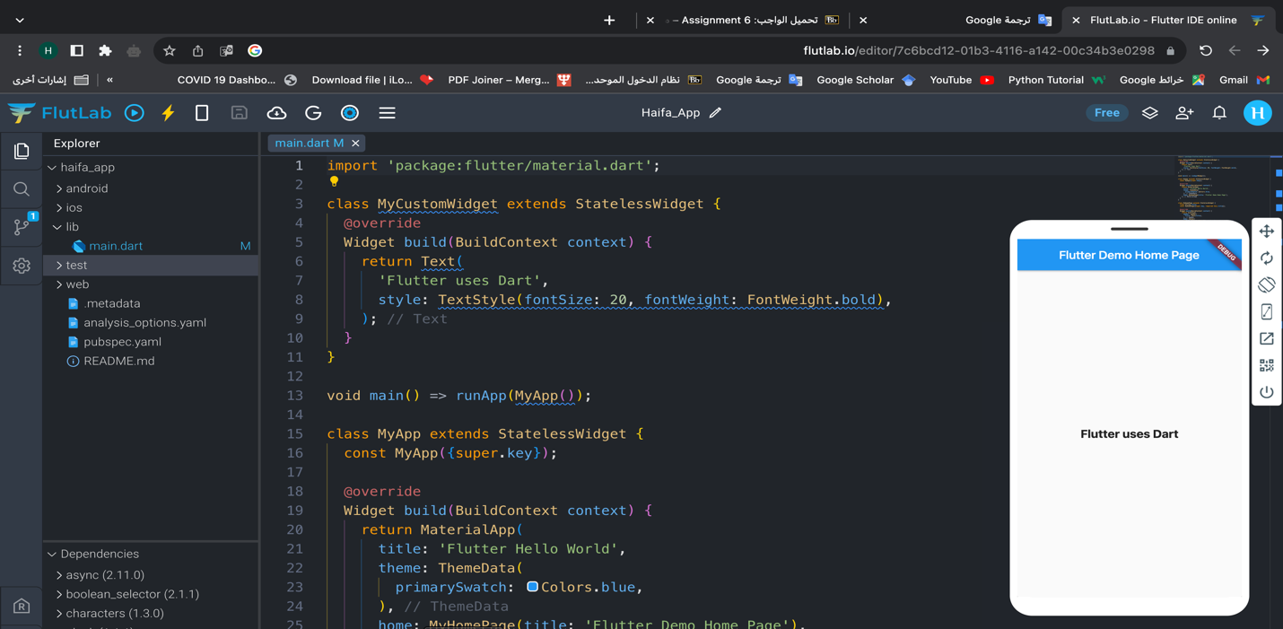

import 'package:flutter/material.dart';

class MyCustomWidget extends StatelessWidget {

@override

Widget build(BuildContext context) {

return Text(

'Flutter uses Dart',

style: TextStyle(fontSize: 20, fontWeight: FontWeight.bold),

);

}

}

void main() => runApp(MyApp());

class MyApp extends StatelessWidget {

const MyApp({super.key});

@override

Widget build(BuildContext context) {

return MaterialApp(

title: 'Flutter Hello World',

theme: ThemeData(

primarySwatch: Colors.blue,

),

home: MyHomePage(title: 'Flutter Demo Home Page'),

);

}

}

class MyHomePage extends StatelessWidget {

final String title;

const MyHomePage({super.key, required this.title});

@override

Widget build(BuildContext context) {

return Scaffold(

appBar: AppBar(

title: Text(title),

),

body: Center(

child: MyCustomWidget(), // Use the custom widget here

),

);

}

}

